Who needs conspiracy theories when the Freemasons openly celebrate Vatican II in the Eternal City?
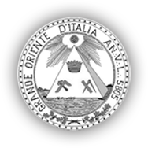
The largest and most influential Masonic organization in Italy is the Grand Orient of Italy [Grande Oriente d'Italia]. Yes, it is the very same Grand Lodge whose Grand Masters always worked for the humiliation of the Apostolic See, from the battles against Pius IX to symbolic acts of effrontery (such as Giordano Bruno's statue in Campo de' Fiori, a response to Leo XIII); it was also the Grand Lodge that once had jurisdiction over the well-known Propaganda Due lodge, the P2, including during the crucial years of the Vatican II Council and immediate aftermath.

This Grande Oriente d'Italia hosted a conference on June 12, 2014, at Palazzo delle Esposizioni, Via Milano, Rome, to promote the book “Il Concilio Segreto” (The Secret Council), by Ignazio Ingrao. On the panel of guests invited to present the book were Marco Politi, journalist and Vaticanist for “La Repubblica” and “Il Fatto Quotidiano”; Alberto Melloni, the very influential historian and a leader of the famous “Bologna School” founded by Giuseppe Alberigo, whose purpose was to establish forevermore the "Spirit of the Council" as the official interpretation of the conciliar documents; Marinella Perroni, theologian, professor at the Pontifical Atheneum of St. Anselm, Rome (the Anselmianum, the Pontifical Benedictine university in Rome), specializing in New Testament Studies; and, last but certainly not least, Stefano Bisi, the newly elected Grand Master of the Grand Lodge. The author, Ignazio Ingrao, a highly relevant Vaticanist, was also present.

The meeting was recorded and can be found here in Radio Radicale in its entirety. To give a general idea of the festive and relaxed ambience, Grand Master Bisi in his remarks is proud to say that a priest he consulted told him he certainly "could receive communion." (Obviously, no contradiction from anyone in the room.)

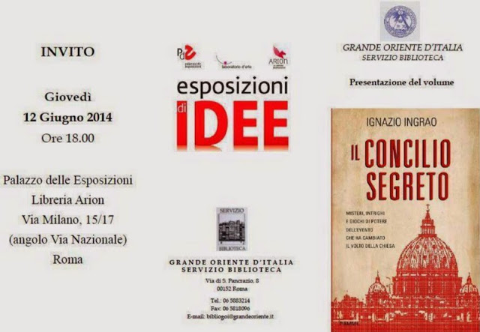
Below is a translation of the flyer the Grand Orient of Italy produced to promote the event:
The Church of Dialogue,
from the Second Vatican Council to Pope Francis

“There is a Council that has never been told, the one that took place far from the limelight, in the secret conferences among bishops and cardinals, in diplomats’ meetings, in reunions among the editorial staff of newspapers, in sections of [political] parties and even among “007’s”[…] There are hosts of Russian, Polish, English, American and of course - Italian spies, who camouflage themselves amidst prelates and listeners, compiling dossiers and even able to influence the conclave that elects Paul VI. Letters from priests who ask Montini to abolish sacerdotal celibacy materialize . There is a theologian who denounces, with courage, the scandal of pedophilia in the Church, but his cry of alarm, remains, alas, unheard.” [*] [**]

To understand an event as innovative and paradigmatic as the Second Vatican Council was, and to do so through a non–official reading, based, however, on testimonies and many unpublished, documents, means having the opportunity of getting to the heart of what is happening in the Church today. The revolutionary act of Benedict XVI, the abdicating Pope, in renouncing the throne, makes [the Pope] a bishop among bishops and fulfills that collegial spirit that had strongly permeated Vatican II; the “surprise” election of Pope Francis, the first bishop in the history of the Church to come from South America to guide the people of Christ - preacher of spiritual renewal, in humility and poverty, a strategic figure in a Church that seems to have lost its center in Old Europe, but is rediscovering itself, alive and fecund, in “the south of the world”, are all developments whose origins are generally recognizable in the unprecedented event, which marked the life of the universal Church between the pontificates of John XXIII and Paul VI.

Unfortunately, the ‘putting into effect’ of the Second Vatican Council during the course of the last fifty years of Church history has met obstacles and difficulties. The Church outlined by the conciliar meetings, i.e. outgoing and open to the world, willing to dialogue and sensitive to those positives seeds of modernity, has not always had an easy life. Fears, resistance and shortsightedness at times, have slowed down this necessary evolution. Many of the reforms on the agenda of Bergoglio’s pontificate refer back to the themes already discussed during the Council: from the family to the role of women, from priestly celibacy to the “poverty” of the Church, to cite just a few.

In short, studying the Council of yesterday will help us to anticipate the Church of tomorrow. Pope Francis has gathered together the testimony of his predecessors and is strongly and decisively committed to the up-to-date implementation of the Council. The Church in a dialogue which is focused on the peripheries, as the Argentine Pope wants, re-proposes the model that the Council Fathers desired. Therefore, a new season of confronting themes which were left hanging has opened up.

An important point of dialogue, even with the secularized and non-believers, is the one of human rights. The commitment to justice, based on the acknowledgement of the fundamental principles of natural law, characterizes the action of the Church on all latitudes and involves, not rarely, a high price to pay, even in terms of attacks and persecutions. The defense of human rights and the acknowledgement of the principles of natural law which guide the common good, may be, therefore, a useful platform to confront and discuss, for all those who have the promotion of the human person at heart.

[The last paragraph is a short presentation of Ignazio Ingrao.]

Apparently, that is the Grand Lodge's position: the Second Vatican Council was an "innovative and paradigmatic" highly positive event, which was not "put into effect" very well -- but the "revolutionary abdication" of Benedict XVI that made the pope "a bishop among bishops" set the stage for its "strong and decisive implementation" by Pope Francis. Grand Master Gustavo Riffi, leader of the Grand Lodge at the time, had set the tone in his congratulating message for the election of Pope Francis: "With Pope Francis, nothing will be as before. The choice of fraternity for a Church of dialogue is clear, uncontaminated by the logic and temptations of temporal power." (March 14, 2013) This was the same Grand Master who had criticized the Italian Episcopal Conference in the 2006 Italian election campaign, in the previous pontificate, for daring to speak up against... abortion, euthanasia, marriage during the campaign. Those days are gone for good, presumably.
_________________________
* This first paragraph is an excerpt from the book -- the remainder of the flyer is the presentation, by the Grand Lodge, of the Council and the present pontificate.
** In fact, much of this secret underground Council, that prepared the Council as it happened in the Vatican Basilica, has already been dissected in many books, not least "The Second Vatican Council", by Roberto de Mattei.

[Post and translation: Contributor Francesca Romana. Tip: Spanish blog Ex Orbe, whose post title is very amusing: "Our Brothers (!?) from the (other) Orient."]
Labels: Freemasonry, Papal Abdication, The Bergoglio Pontificate, Vatican II at 50
Posted by New Catholic at 6/23/2014 12:00:00 AM

