St. Andrew Christmas Novena Prayer

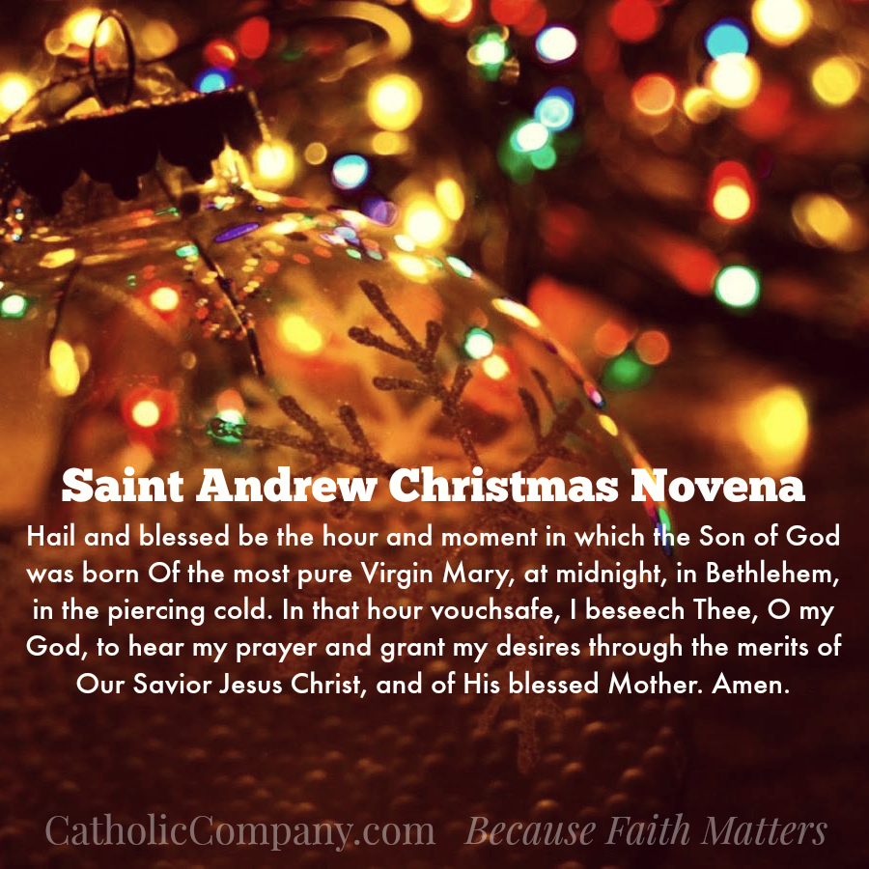
Prayer is an essential part of Advent. Reciting this special novena prayer each day is a simple yet beautiful way to celebrate the spiritual significance of the Advent season and to experience a deeper conversion to the heart of Jesus. The St. Andrew Christmas novena is commonly found in many Advent prayer books which are also loaded with many other beautiful prayers and traditions for this time of year.

